

Fundamentals in AI&ML
(CSA2001)

Shraddha Gupta
25BAI10347
Btech CSE AIML

AI – POWERED CAMPUS GRIEVANCE TRIAGE AGENT

Overview:

In large academic institutions, handling student grievances efficiently is a major challenge. Complaints are often submitted manually or through basic systems, leading to delays, misclassification, and lack of prioritization. This project proposes an AI-powered grievance triage system that automates the classification, prioritization, and routing of complaints.
The system integrates Machine Learning, Natural Language Processing (NLP), and rule-based logic to intelligently process student complaints and determine the appropriate department and urgency level.

Problem Statement:

What?:

Traditional grievance handling systems suffer from the following issues:
- Manual sorting of complaints is time-consuming
- Lack of prioritization can delay critical issues
- Misrouting of complaints to incorrect departments
- No understanding of emotional urgency in complaints

The goal of this project is to design a system that can:

- Automatically classify complaints into departments
- Detect emergency situations instantly
- Analyze user sentiment to adjust priority
- Reduce response time and improve efficiency

Why?

I chose this project because grievance handling is a common issue in colleges, where complaints are often delayed, misrouted, or ignored due to manual processing.

System Overview:

The system works as a pipeline:
Input Complaint → Logic Rules → ML Classification → Sentiment Analysis → Output Decision
Each module contributes to decision-making, ensuring both accuracy and speed.

Working of the agent:

    - Data Collection – I created a dataset of sample complaints and labelled them with corresponding departments such as IT, maintenance, academics,etc.

    - Data Processing –

- Text Cleaning
- Lowercasing
- Removal of unnecessary symbols
    - Model Training - A classification model is trained using the dataset to predict the department based on complaint text. The trained model is saved as a .pkl file for reuse.
    - Rule Based Logic – A set of predefined rules is used to detect emergency keywords such as “fire”, “electric shock”, etc. This ensures immediate handling without relying on ML.
    - Sentiment Analysis – It is used to determine the frustration level of the user so that the model can define the urgency of the complaint.

Implementation Details:

- model_training.py
- Loads dataset
- Trains classification model
- Saves model using pickle
- logic_rules.py
- Implements emergency detection using keyword matching
- sentiment_analyzer.py
- Uses NLP techniques to determine emotional intensity
- triage_agent.py
- Main execution file
- Integrates all modules
- Processes user input and generates final output

Key Decisions Made:

Combined rule based and ML approaches for reliability
Used serialized models like .pkl to avoid retraining
Modular design for easy maintenance & scalability
Prioritizing interpretability over overly complex models

Challenges Faced:

Limited dataset size affecting model accuracy
Handling ambiguous complaint text
Balancing between rule-based and ML decisions
Ensuring correct file paths and model loading

Result:

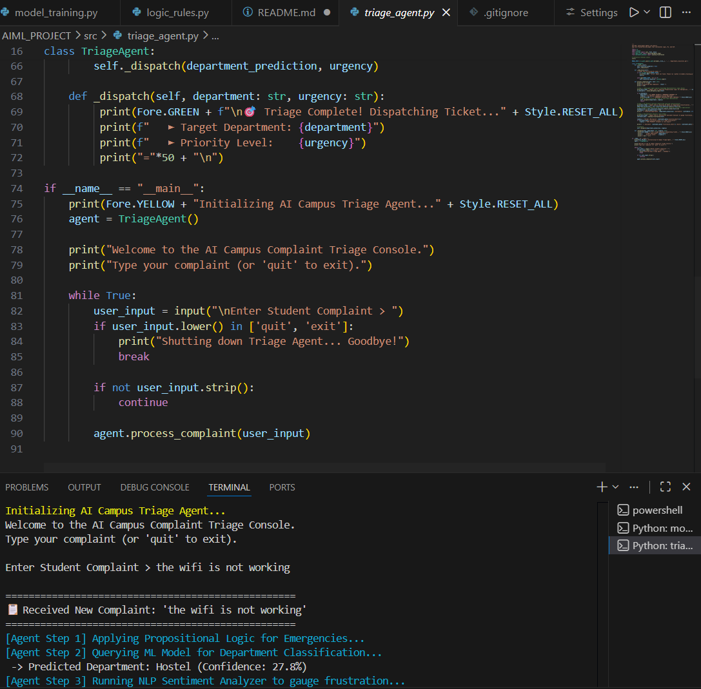
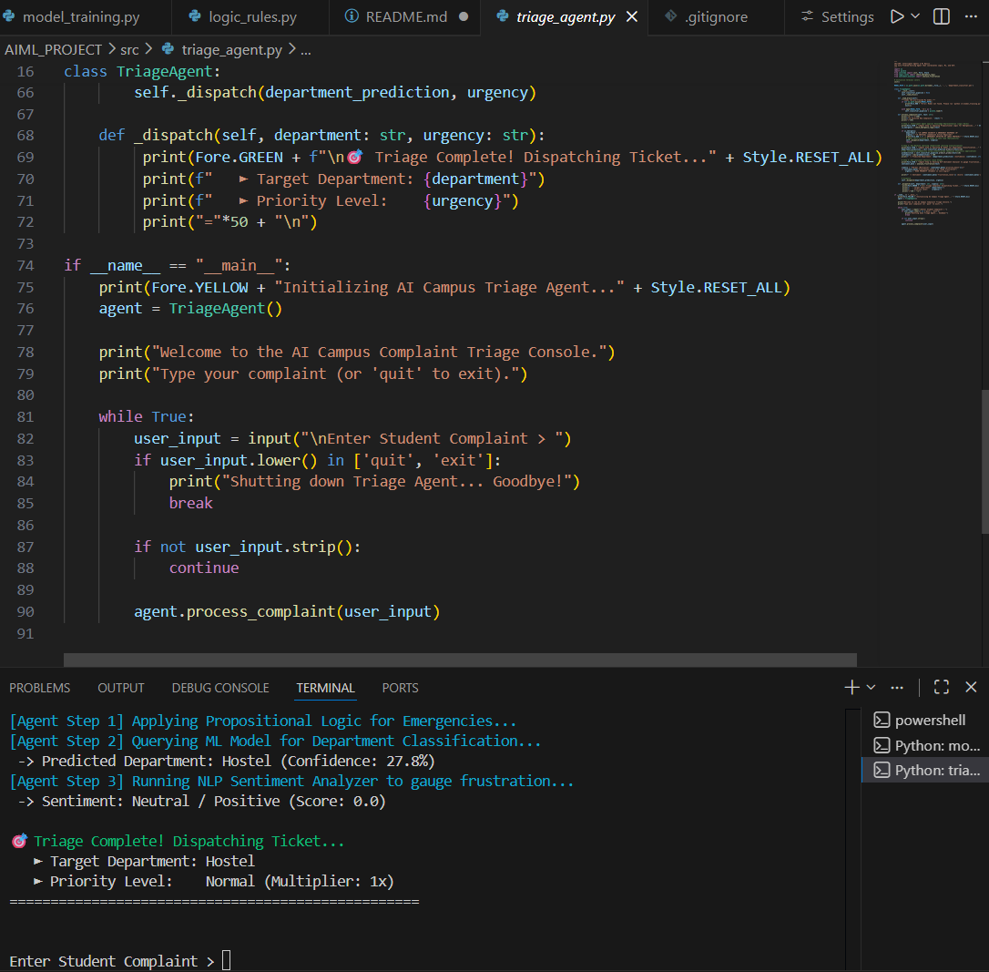
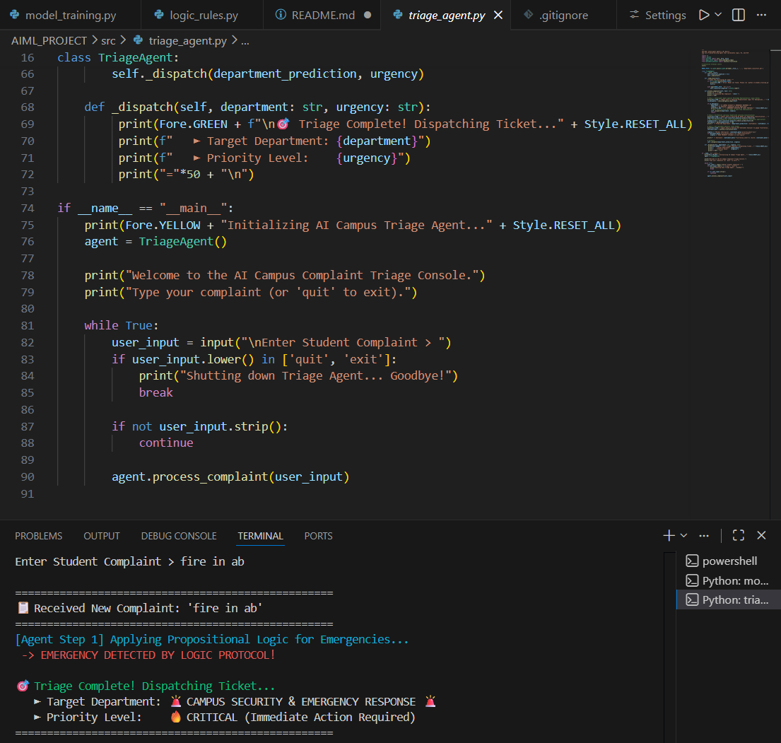

Conclusion:

This project shows how with the use of simple programs we can solve such time consuming real world problems.

